#
# 20180914

[root@m1-postgresql83p ~]# puppet agent -t

[root@m1-postgresql83p ~]# id ima
uid=816(ima) gid=816(ima) groups=816(ima),0(root),10(wheel)
[root@m1-postgresql83p ~]#

[root@m1-postgresql83p ~]# scp bsv@ds-postgresql01p:/etc/yum.repos.d/pgdg-96-redhat.repo /etc/yum.repos.d/
bsv@ds-postgresql01p's password:
pgdg-96-redhat.repo 100% 215 63.1KB/s 00:00
[root@m1-postgresql83p ~]#

[root@m1-postgresql83p ~]# yum repolist

[root@m1-postgresql83p ~]# sysctl -p /etc/sysctl.d/98-postgres.conf
vm.nr_hugepages = 2129
kernel.shmall = 2097152
kernel.shmmax = 8589934592
vm.hugetlb_shm_group = 26
vm.swappiness = 1
vm.overcommit_memory = 2
kernel.numa_balancing = 0
net.core.somaxconn = 1024
net.core.netdev_max_backlog = 1000
[root@m1-postgresql83p ~]#

#
# Simpana exists.
#
[root@m1-postgresql83p ~]# cat $(puppet agent --configprint classfile)
settings
__node_regexp__m1ds-postgresql6-90-9pt.tcsbank.ru
role::postgres
profile::base
profile::base::repos_el
tcs_repos::epel
tcs_repos::puppet5
tcs_repos::centos
profile::base::selinux
selinux::params
selinux
selinux::package
selinux::config
profile::base::ntp
ntp
ntp::install
ntp::config
ntp::service
profile::base::packages
profile::base::sysstat_config
profile::base::firewall
firewalld
profile::accounts::admins
profile::accounts::nessus
profile::base::nrpe
tcs_nrpe::params
tcs_nrpe
tcs_nrpe::install
tcs_nrpe::config
tcs_nrpe::service
profile::base::puppet_agent
profile::base::sysctl
sysctl::params
sysctl::base
profile::postgres
customfact::dmimem
profile::postgres::limits
limits
profile::postgres::repo
tcs_repos::pgdb_rpm
profile::postgres::thp
profile::postgres::postfix
profile::postgres::sudo
sudo::params
sudo
sudo::package
sudo::configs
profile::accounts::params
profile::accounts::ima
profile::accounts::oradba
profile::simpana::install
[root@m1-postgresql83p ~]#

[root@m1-postgresql83p ~]# mkdir -p /data/apitravel/ /pgsys/apitravel/ /arch/apitravel/

[root@ds-postgresql83p ~]# cat /etc/fstab

#
# /etc/fstab
# Created by anaconda on Thu Sep 15 11:33:57 2016
#
# Accessible filesystems, by reference, are maintained under '/dev/disk'
# See man pages fstab(5), findfs(8), mount(8) and/or blkid(8) for more info
#
/dev/mapper/vg_root-lvol0 / xfs defaults 0 0
/swap swap swap sw 0 0
UUID=f558dac6-0cbf-4049-b349-be4aa894c26b /boot xfs defaults 0 0

#SD#1745217
a700-pgsql-prod-nfs:/PGSQL_apitravel_ds /data/apitravel nfs rw,bg,vers=3,tcp,timeo=600,rsize=65536,wsize=65536,hard 0 0
a700-pgsql-prod-nfs:/PGSQL_apitravel_pgsys_ds /pgsys/apitravel nfs rw,bg,vers=3,tcp,timeo=600,rsize=65536,wsize=65536,hard 0 0
a700-pgsql-prod-nfs:/PGSQL_apitravel_arch_ds /arch/apitravel nfs rw,bg,vers=3,tcp,timeo=600,rsize=65536,wsize=65536,hard 0 0
[root@ds-postgresql83p ~]#

[root@ds-postgresql83p ~]# for var1 in /data/apitravel/ /pgsys/apitravel/ /arch/apitravel/ ; do mount -v ${var1} ; done
mount.nfs: trying text-based options 'bg,vers=3,tcp,timeo=600,rsize=65536,wsize=65536,hard,addr=10.217.164.253'
mount.nfs: prog 100003, trying vers=3, prot=6
mount.nfs: trying 10.217.164.253 prog 100003 vers 3 prot TCP port 2049
mount.nfs: prog 100005, trying vers=3, prot=6
mount.nfs: trying 10.217.164.253 prog 100005 vers 3 prot TCP port 635
mount.nfs: trying text-based options 'bg,vers=3,tcp,timeo=600,rsize=65536,wsize=65536,hard,addr=10.217.164.253'
mount.nfs: prog 100003, trying vers=3, prot=6
mount.nfs: trying 10.217.164.253 prog 100003 vers 3 prot TCP port 2049
mount.nfs: prog 100005, trying vers=3, prot=6
mount.nfs: trying 10.217.164.253 prog 100005 vers 3 prot TCP port 635
mount.nfs: trying text-based options 'bg,vers=3,tcp,timeo=600,rsize=65536,wsize=65536,hard,addr=10.217.164.253'
mount.nfs: prog 100003, trying vers=3, prot=6
mount.nfs: trying 10.217.164.253 prog 100003 vers 3 prot TCP port 2049
mount.nfs: prog 100005, trying vers=3, prot=6
mount.nfs: trying 10.217.164.253 prog 100005 vers 3 prot TCP port 635
[root@ds-postgresql83p ~]#

[root@ds-postgresql83p ~]# df -hT /data/apitravel/ /pgsys/apitravel/ /arch/apitravel/
Filesystem Type Size Used Avail Use% Mounted on
a700-pgsql-prod-nfs:/PGSQL_apitravel_ds nfs 1.3T 384K 1.2T 1% /data/apitravel
a700-pgsql-prod-nfs:/PGSQL_apitravel_pgsys_ds nfs 50G 320K 50G 1% /pgsys/apitravel
a700-pgsql-prod-nfs:/PGSQL_apitravel_arch_ds nfs 200G 320K 200G 1% /arch/apitravel
[root@ds-postgresql83p ~]#

...........................................................................

[root@vm-vol-nag4-tst objects]# vim -o servers/vmware/postgresql/{ds-postgresql01p,ds-postgresql83p}.cfg
2 files to edit
[root@vm-vol-nag4-tst objects]# vim -o servers/vmware/postgresql/{ds-postgresql01p,m1-postgresql83p}.cfg
2 files to edit
[root@vm-vol-nag4-tst objects]# service nagios checkconfig && service nagios reload
Running configuration check...
OK.
Running configuration check...
Reloading nagios configuration...
done
[root@vm-vol-nag4-tst objects]#

[root@vm-vol-nag4-tst objects]# git add servers/vmware/postgresql/ds-postgresql83p.cfg servers/vmware/postgresql/m1-postgresql83p.cfg
[root@vm-vol-nag4-tst objects]# git commit --author='Sergey Belogrud <s.belogrud@tinkoff.ru>' -m "SD#1745217. Were created two new host for monitoring." servers/vmware/postgresql/ds-postgresql83p.cfg servers/vmware/postgresql/m1-postgresql83p.cfg
[master 428320c] SD#1745217. Were created two new host for monitoring.
Author: Sergey Belogrud <s.belogrud@tinkoff.ru>
2 files changed, 48 insertions(+), 0 deletions(-)
create mode 100644 objects/servers/vmware/postgresql/ds-postgresql83p.cfg
create mode 100644 objects/servers/vmware/postgresql/m1-postgresql83p.cfg
[root@vm-vol-nag4-tst objects]#

[root@vm-vol-nag4-tst objects]# git pull && git push
Already up-to-date.
Counting objects: 13, done.
Delta compression using up to 4 threads.
Compressing objects: 100% (8/8), done.
Writing objects: 100% (8/8), 924 bytes, done.
Total 8 (delta 6), reused 0 (delta 0)
To git@vm-gitlab01.tcsbank.ru:nagios-core/nag4-base.git
30ae311..428320c master -> master
[root@vm-vol-nag4-tst objects]#

# SD#2075387
# https://sd.tcsbank.ru/0/NUI/ViewModule.aspx#CardModuleV2/CasePage/edit/e433ef75-cb3b-428d-b9db-876554add8fd
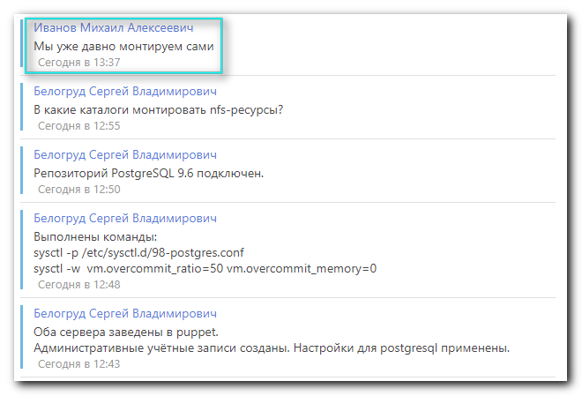
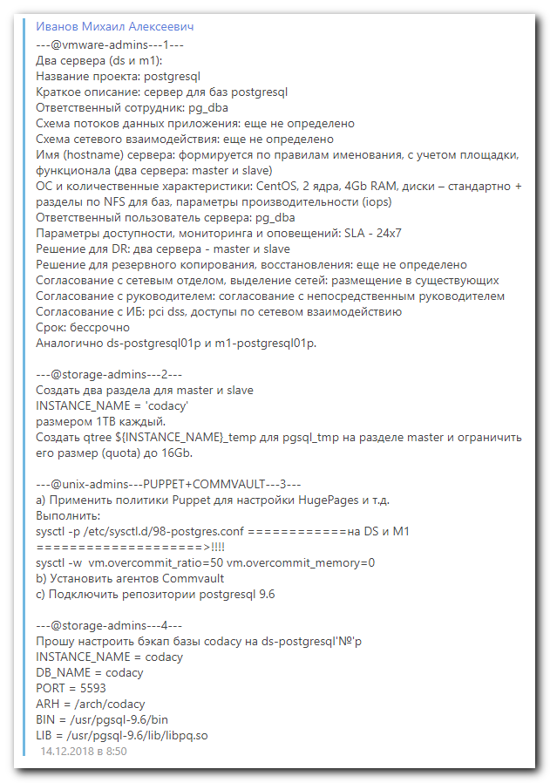

#
# 20190218
# SD#2299539
# https://sd.tcsbank.ru/0/NUI/ViewModule.aspx#CardModuleV2/CasePage/edit/fd220106-51dd-4584-92ad-a23d041280b2

